**FRAME**

# Objective

* Structure the car and ensure the position and the sustainability of other systems
* Ensure the pilot security

# Conception steps:

Step 1: The rules imposed few extremal dimensions as the size of the cockpit, the front of the frame and also the position of tubes on the side impact.

Step 2: Suspension preference-based conception.

Step 3: Make the integration of the engine easier thanks to removable bracings.

Step 4: Improve the pilot position making it more comfortable. Minimization of the front hoop in order to improve the pilot visibility.

# Important values

* Stiffness
  + Target: 1000-1500 Nm/deg
  + Simulation: 1114 Nm/deg
  + Measure: 1205 Nm/deg
* Weight with paint and equipment
  + Target: 39-42 kg
  + Simulation: 40.6 kg
  + Measure: 41 kg
* Steel: 25CD4S (AISI4130)
  + Yield strength: 7.108 N/m²

# Simulation

## Hypothesis

* Elastic behaviour
* Small displacement
* Welds infinitely stiff
* No dynamic phenomenon
* Beam model

## Results

NB: Except for torsion , all load cases come from MécaMaster

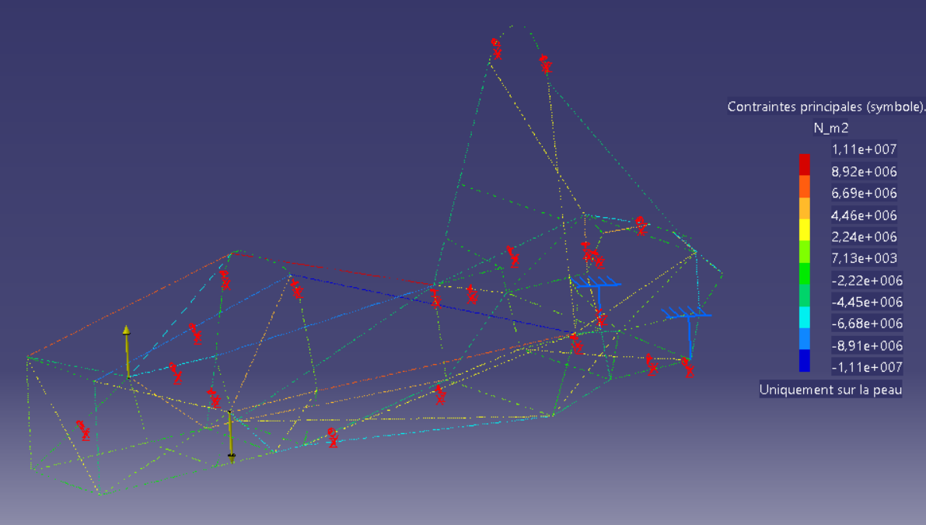

Figure 1: Torsion

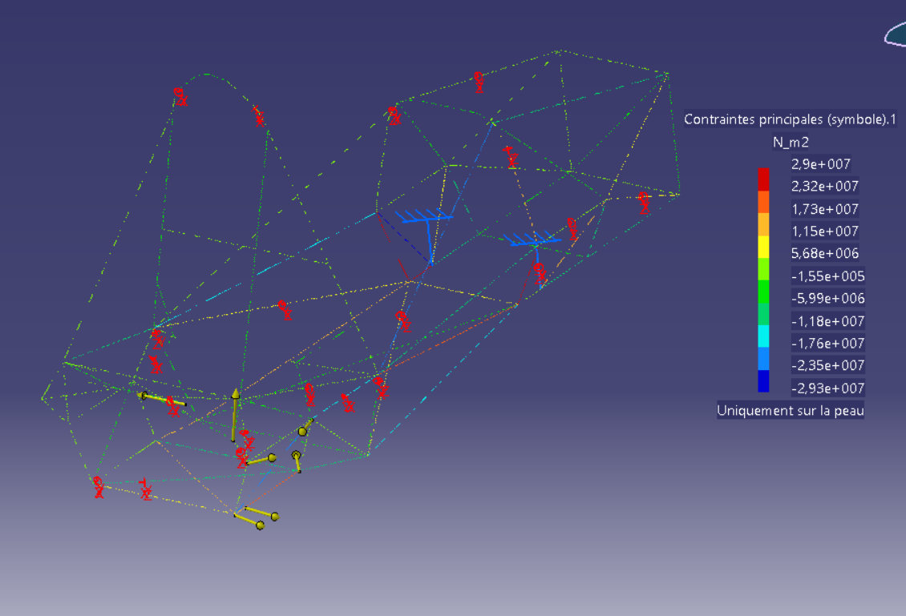

Figure 2a: Acceleration 0.77g

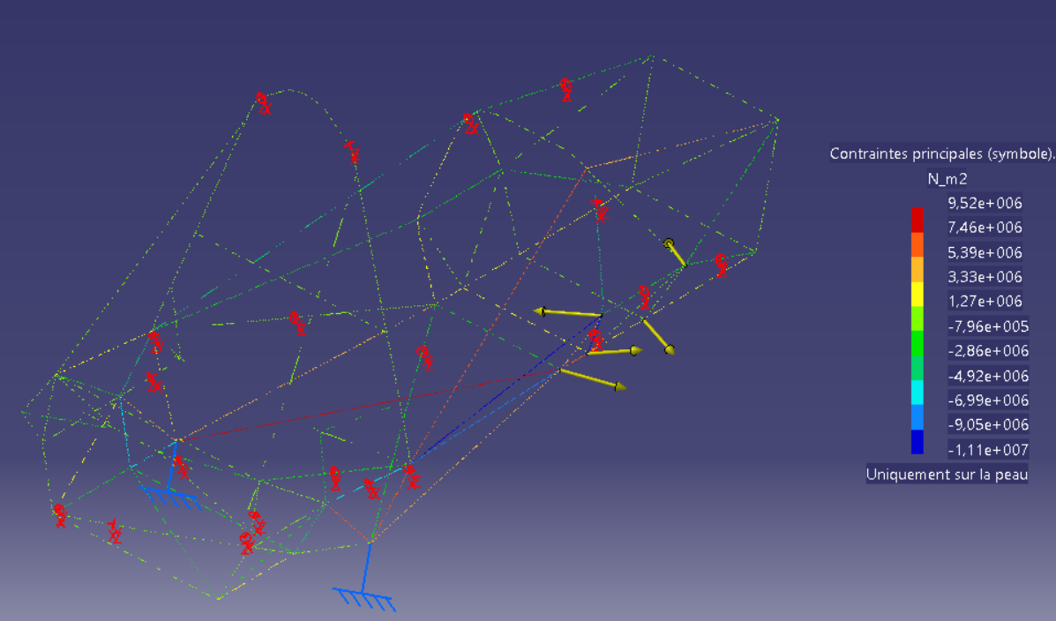

Figure 2b: Acceleration 0.77g

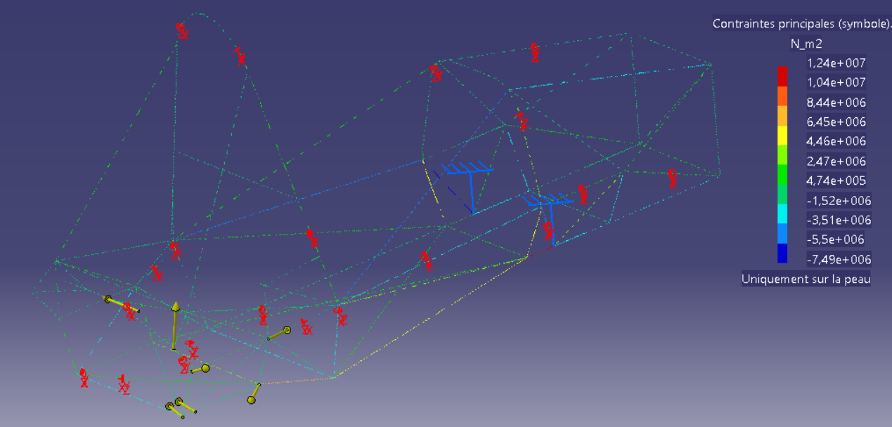

Figure 3a: Braking 2g

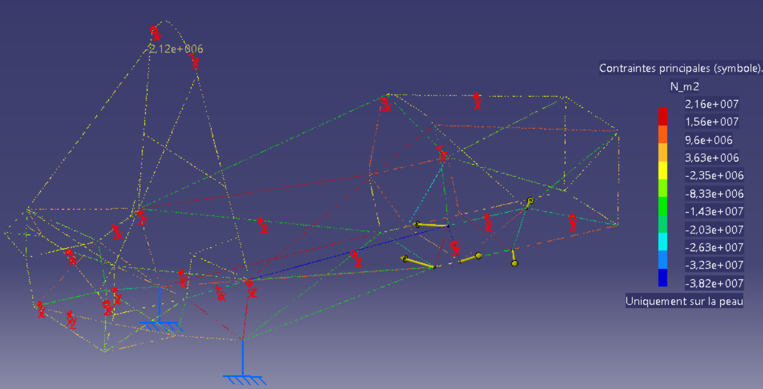

Figure 3b: Braking 2g

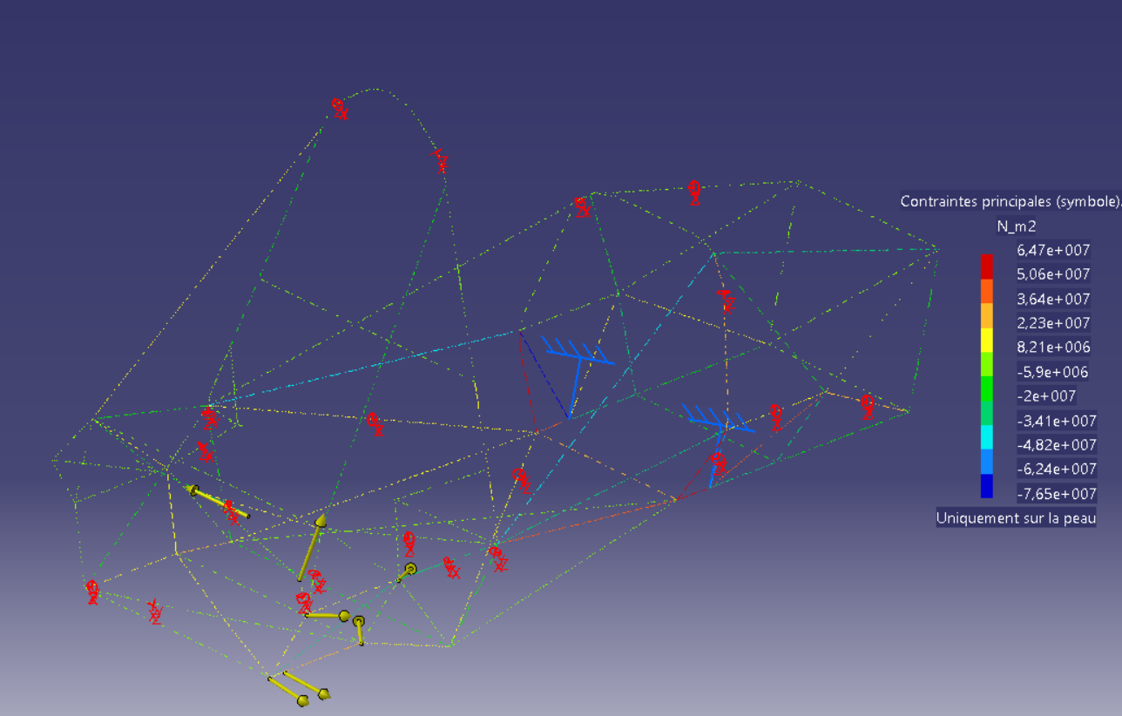

Figure 4a: Bump 3g

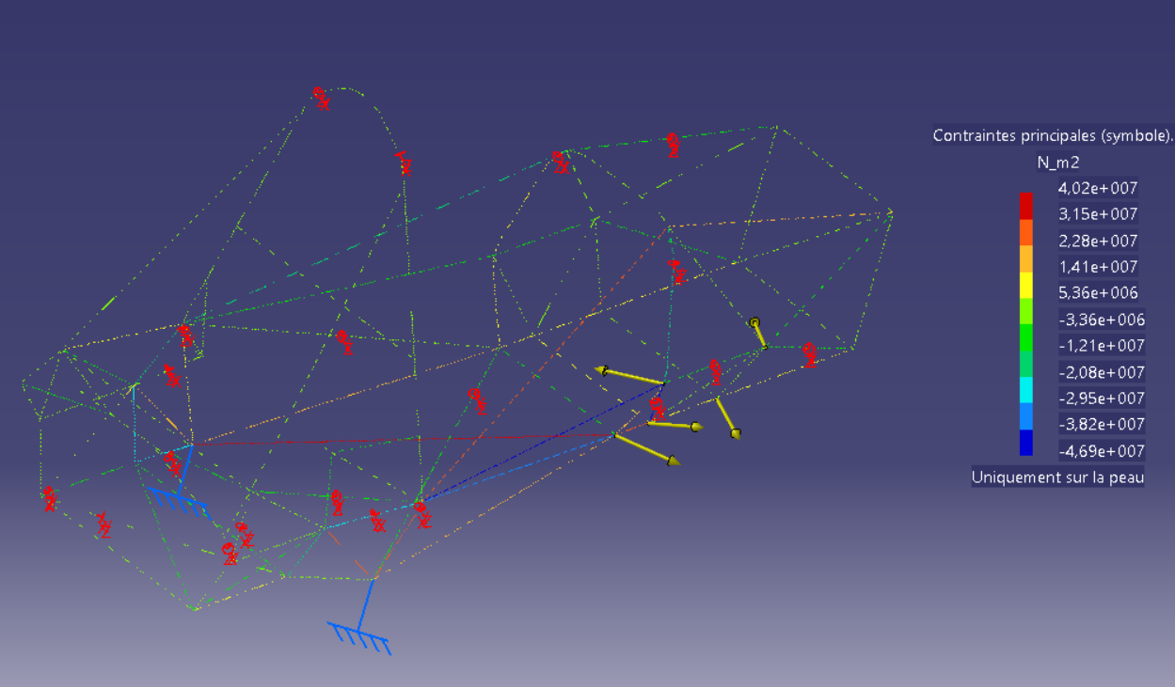

Figure 4b: Bump 3g

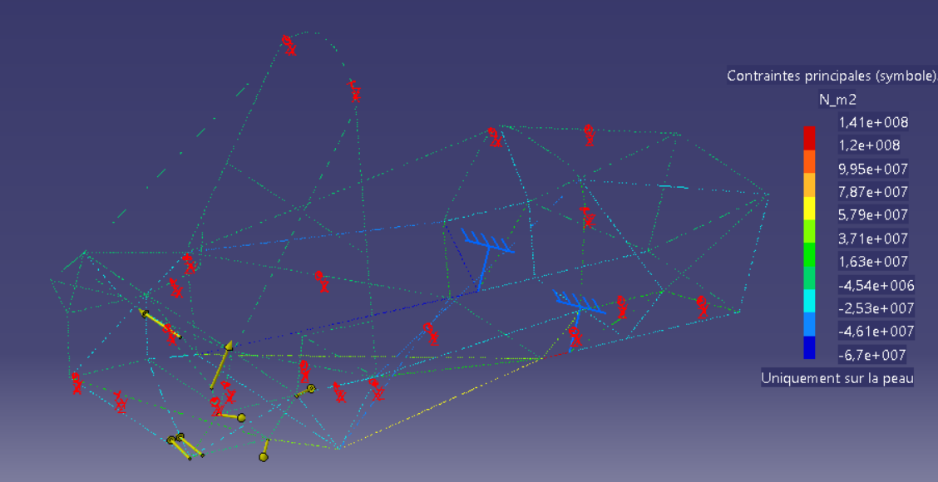

Figure 5a: Left turn 2g



Figure 5b: Left turn 2g

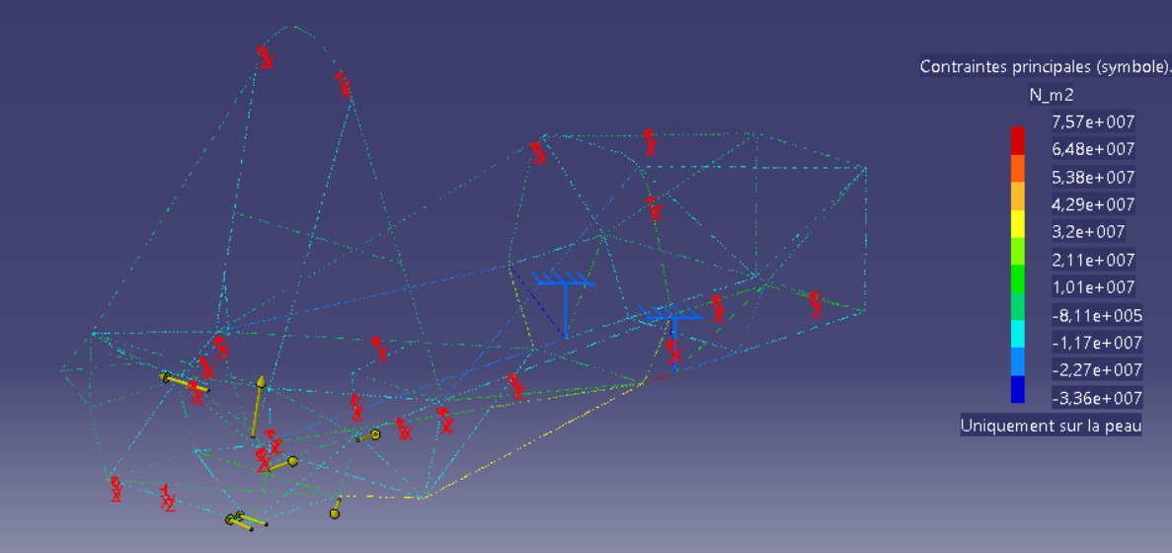

Figure 6a: Left turn 1g + braking 1g

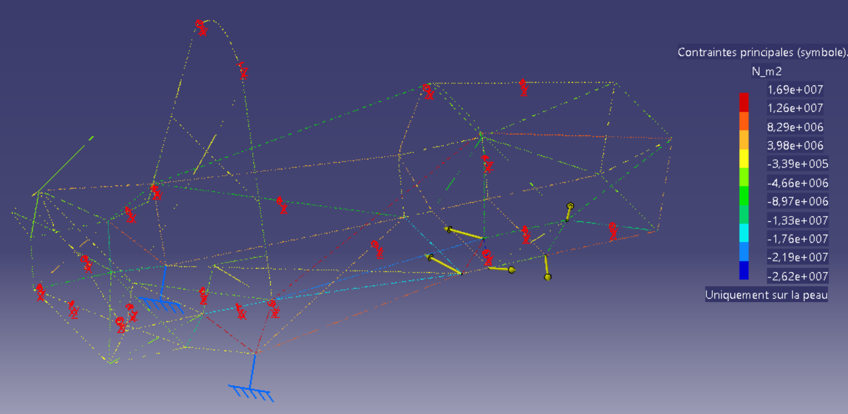

Figure 6b: Left turn 1g + braking 1g

# Stiffness measure experiment

# 

Figure 7: Stiffness measurement on the frame

Measure performed in two times:

* Apply a torque to the front and the cockpit of the frame, blocking the back
* Apply a torque at the back, blocking the front

The difference between the simulated and the measured values may come from the boundaries conditions that are not exactly the same.

# Equipment positioning

Une image contenant personne, intérieur, mur, cuisine

Description générée avec un niveau de confiance très élevé

Figure 8: Use of templates to precisely positioned equipment during welding

# Appendix

## Stiffness model (coefficient )

Frame: 3 series torsion springs

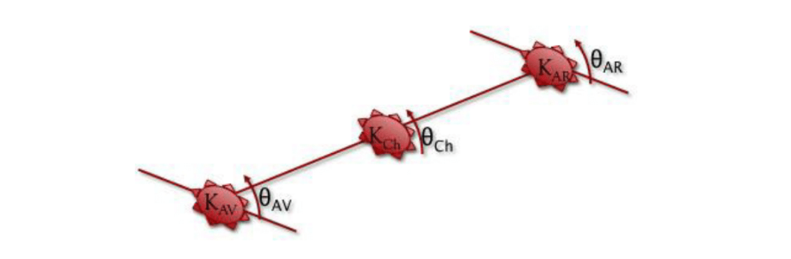

Figure 9: Definition of the model

Where K=stiffness and Θ=angle. We also define and respectively the stiffness and the angle of the car.

In order to simplify the equations, we suppose . It gives us the following equations:

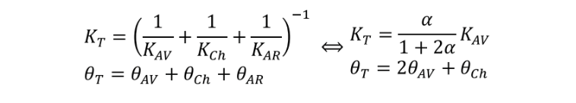

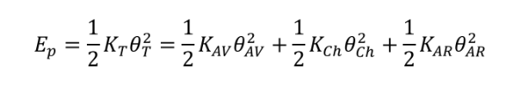

Finally,

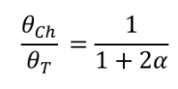

Figure 9: Coefficient of relative stiffness regarding suspension

If we want to keep between 10% and 15%, we have to take α between 3 and 5.

## Pilot position

# Une image contenant transport, ciel, intérieur Description générée avec un niveau de confiance élevé

Figure 10: Human model in CAD model to help designing the chassis